1. 1. IP: 192.168.1.102
   2. TCP: 1161
2. 1. IP: 128.11.245.12
   2. TCP: 80
3. 1. IP: 10.197.137.11
   2. 55438
4. 1. Seq: 0
   2. [SYN], in info is set to 1
5. 1. Seq: 0
   2. Ack: 1
   3. It has received seq: 0 and the server adds 1 and returns
   4. [SYN, ACK], flags set to 1
6. 1. Seq: 1
7. Look at table
8. Look at table

| Segment | Seq Num | length | Sent (6:44:20.##) | ACK (6:44:20.##) | RTT | ERTT |
| --- | --- | --- | --- | --- | --- | --- |
| 1 | 1 | 565 | 596858 | 593646 | -3212 | -3212 |
| 2 | 566 | 1460 | 612118 | 624318 | 12220 | -1285.5 |
| 3 | 2026 | 1460 | 624407 | 647675 | 23268 | 2746.19 |
| 4 | 3486 | 1460 | 625071 | 694466 | 69395 | 11077.29 |
| 5 | 4946 | 1460 | 647786 | 739499 | 91713 | 21156.75 |
| 6 | 6406 | 1460 | 648538 | 787680 | 139142 | 35904.9 |

1. Calculated window size: 17520, no it does not throttle
2. No, the seq number uses different times

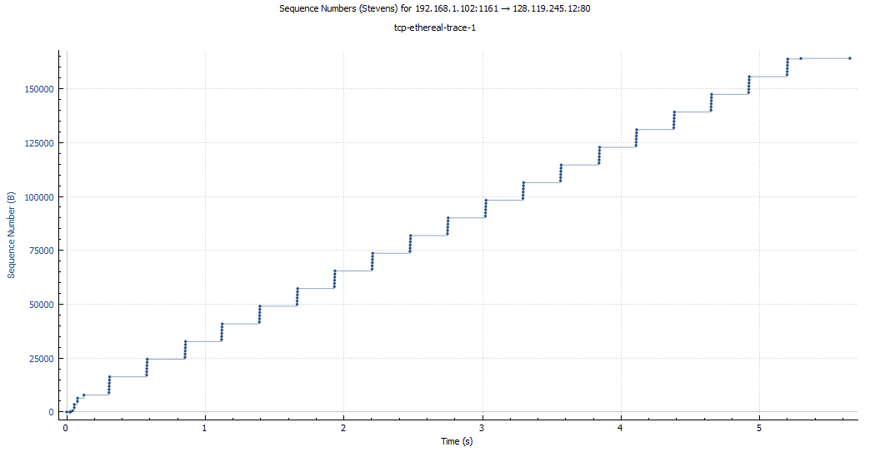

1. (17520+6780+8760+11680+14600+17520)/6 = 12810 ave.
2. Throughput = amount / time,

~~3.175135 kb/sec = 164091 / 51680~~

187K bits captured, 185K bits displayed per second

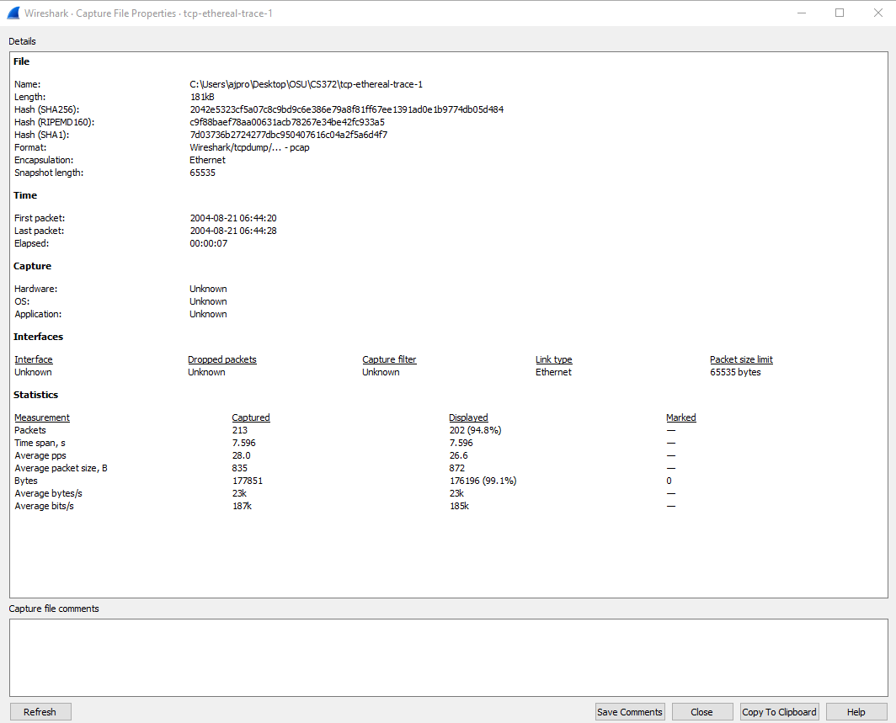

1. It's slowest for the first 0.25 seconds until it starts to stabilize in congestion avoidance. This graph is staggered and not linear.
2. 1. 435K bits captures, 838K displayed
   2. The graph slows in multiple locations, most notably at [(0.35,0.4), (0.45, 0.7), (0.575, 0.65), (0.84, 0.87), (1.75, 1.9)]

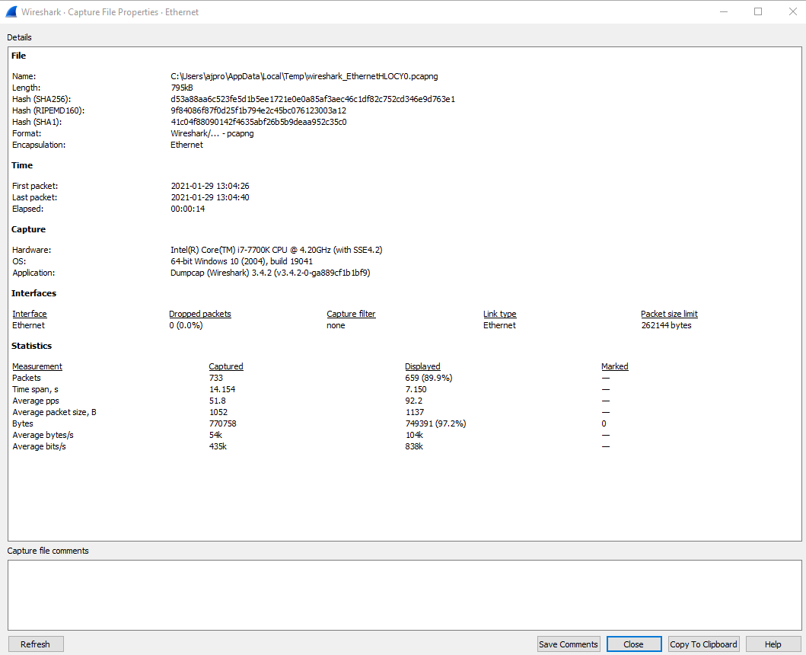

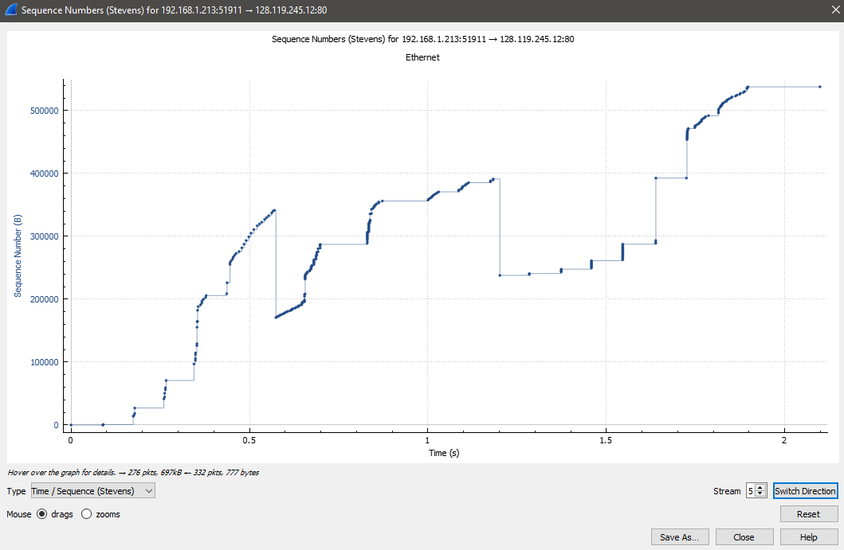

Segment prints used:

1.

A:\Downloads\tcp-ethereal-trace-1 213 total packets, 2 shown

No. Time Source Destination Protocol Length Info

199 06:44:25.867722 192.168.1.102 128.119.245.12 HTTP 104 POST /ethereal-labs/lab3-1-reply.htm HTTP/1.1

(text/plain)

Frame 199: 104 bytes on wire (832 bits), 104 bytes captured (832 bits)

Ethernet II, Src: Actionte_8a:70:1a (00:20:e0:8a:70:1a), Dst: LinksysG_da:af:73 (00:06:25:da:af:73)

Internet Protocol Version 4, Src: 192.168.1.102, Dst: 128.119.245.12

Transmission Control Protocol, Src Port: 1161, Dst Port: 80, Seq: 164041, Ack: 1, Len: 50

[122 Reassembled TCP Segments (164090 bytes): #4(565), #5(1460), #7(1460), #8(1460), #10(1460), #11(1460), #13(1147), #18(1460),

#19(1460), #20(1460), #21(1460), #22(1460), #23(892), #30(1460), #31(1460), #32(1460), #33(1460), #34(1460), #3]

Hypertext Transfer Protocol

MIME Multipart Media Encapsulation, Type: multipart/form-data, Boundary: "---------------------------265001916915724"

3.

C:\Users\ajpro\AppData\Local\Temp\wireshark_Ethernet 2AZB0X0.pcapng 1071 total packets, 2 shown

No. Time Source Destination Protocol Length Info

968 16:39:12.979874 10.197.137.11 128.119.245.12 HTTP 562 POST /wireshark-labs/lab3-1-reply.htm HTTP/1.1

(text/plain)

Frame 968: 562 bytes on wire (4496 bits), 562 bytes captured (4496 bits) on interface \Device\NPF_{8836CAE8-B590-4268-8C15-

AEE0DD00266E}, id 0

Ethernet II, Src: Cisco_3c:7a:00 (00:05:9a:3c:7a:00), Dst: CIMSYS_33:44:55 (00:11:22:33:44:55)

Internet Protocol Version 4, Src: 10.197.137.11, Dst: 128.119.245.12

Transmission Control Protocol, Src Port: 55438, Dst Port: 80, Seq: 537373, Ack: 1, Len: 508

[476 Reassembled TCP Segments (537880 bytes): #40(711), #41(1350), #42(1350), #43(1350), #44(1350), #45(1350), #46(1350), #47(1350),

#48(1350), #49(1350), #51(1350), #53(1350), #54(1350), #55(711), #57(1350), #58(1350), #59(1350), #60(1350)]

Hypertext Transfer Protocol

MIME Multipart Media Encapsulation, Type: multipart/form-data, Boundary: "----WebKitFormBoundaryNhQPbs8vmUHlNzBm"

4.

A:\Downloads\tcp-ethereal-trace-1 213 total packets, 202 shown

No. Time Source Destination Protocol Length Info

1 06:44:20.570381 192.168.1.102 128.119.245.12 TCP 62 1161 → 80 [SYN] Seq=0 Win=16384 Len=0 MSS=1460

SACK_PERM=1

Frame 1: 62 bytes on wire (496 bits), 62 bytes captured (496 bits)

Ethernet II, Src: Actionte_8a:70:1a (00:20:e0:8a:70:1a), Dst: LinksysG_da:af:73 (00:06:25:da:af:73)

Internet Protocol Version 4, Src: 192.168.1.102, Dst: 128.119.245.12

Transmission Control Protocol, Src Port: 1161, Dst Port: 80, Seq: 0, Len: 0

5.

A:\Downloads\tcp-ethereal-trace-1 213 total packets, 202 shown

No. Time Source Destination Protocol Length Info

2 06:44:20.593553 128.119.245.12 192.168.1.102 TCP 62 80 → 1161 [SYN, ACK] Seq=0 Ack=1 Win=5840 Len=0

MSS=1460 SACK_PERM=1

Frame 2: 62 bytes on wire (496 bits), 62 bytes captured (496 bits)

Ethernet II, Src: LinksysG_da:af:73 (00:06:25:da:af:73), Dst: Actionte_8a:70:1a (00:20:e0:8a:70:1a)

Internet Protocol Version 4, Src: 128.119.245.12, Dst: 192.168.1.102

Transmission Control Protocol, Src Port: 80, Dst Port: 1161, Seq: 0, Ack: 1, Len: 0

6.

A:\Downloads\tcp-ethereal-trace-1 213 total packets, 202 shown

No. Time Source Destination Protocol Length Info

4 06:44:20.596858 192.168.1.102 128.119.245.12 TCP 619 1161 → 80 [PSH, ACK] Seq=1 Ack=1 Win=17520

Len=565

Frame 4: 619 bytes on wire (4952 bits), 619 bytes captured (4952 bits)

Ethernet II, Src: Actionte_8a:70:1a (00:20:e0:8a:70:1a), Dst: LinksysG_da:af:73 (00:06:25:da:af:73)

Internet Protocol Version 4, Src: 192.168.1.102, Dst: 128.119.245.12

Transmission Control Protocol, Src Port: 1161, Dst Port: 80, Seq: 1, Ack: 1, Len: 565

Data (565 bytes)

Data: 504f5354202f657468657265616c2d6c6162732f6c6162332d312d7265706c792e68746d…

[Length: 565]

7.

A:\Downloads\tcp-ethereal-trace-1 213 total packets, 202 shown

No. Time Source Destination Protocol Length Info

3 06:44:20.593646 192.168.1.102 128.119.245.12 TCP 54 1161 → 80 [ACK] Seq=1 Ack=1 Win=17520 Len=0

4 06:44:20.596858 192.168.1.102 128.119.245.12 TCP 619 1161 → 80 [PSH, ACK] Seq=1 Ack=1 Win=17520

Len=565

5 06:44:20.612118 192.168.1.102 128.119.245.12 TCP 1514 1161 → 80 [PSH, ACK] Seq=566 Ack=1 Win=17520

Len=1460

6 06:44:20.624318 128.119.245.12 192.168.1.102 TCP 60 80 → 1161 [ACK] Seq=1 Ack=566 Win=6780 Len=0

7 06:44:20.624407 192.168.1.102 128.119.245.12 TCP 1514 1161 → 80 [ACK] Seq=2026 Ack=1 Win=17520 Len=1460

8 06:44:20.625071 192.168.1.102 128.119.245.12 TCP 1514 1161 → 80 [ACK] Seq=3486 Ack=1 Win=17520 Len=1460

9 06:44:20.647675 128.119.245.12 192.168.1.102 TCP 60 80 → 1161 [ACK] Seq=1 Ack=2026 Win=8760 Len=0

10 06:44:20.647786 192.168.1.102 128.119.245.12 TCP 1514 1161 → 80 [ACK] Seq=4946 Ack=1 Win=17520 Len=1460

11 06:44:20.648538 192.168.1.102 128.119.245.12 TCP 1514 1161 → 80 [ACK] Seq=6406 Ack=1 Win=17520 Len=1460

12 06:44:20.694466 128.119.245.12 192.168.1.102 TCP 60 80 → 1161 [ACK] Seq=1 Ack=3486 Win=11680 Len=0

13 06:44:20.694566 192.168.1.102 128.119.245.12 TCP 1201 1161 → 80 [PSH, ACK] Seq=7866 Ack=1 Win=17520

Len=1147

14 06:44:20.739499 128.119.245.12 192.168.1.102 TCP 60 80 → 1161 [ACK] Seq=1 Ack=4946 Win=14600 Len=0

15 06:44:20.787680 128.119.245.12 192.168.1.102 TCP 60 80 → 1161 [ACK] Seq=1 Ack=6406 Win=17520 Len=0

12.

A:\Downloads\tcp-ethereal-trace-1 213 total packets, 202 shown

No. Time Source Destination Protocol Length Info

206 06:44:26.221522 192.168.1.102 128.119.245.12 TCP 54 1161 → 80 [ACK] Seq=164091 Ack=731 Win=16790

Len=0

Frame 206: 54 bytes on wire (432 bits), 54 bytes captured (432 bits)

Ethernet II, Src: Actionte_8a:70:1a (00:20:e0:8a:70:1a), Dst: LinksysG_da:af:73 (00:06:25:da:af:73)

Internet Protocol Version 4, Src: 192.168.1.102, Dst: 128.119.245.12

Transmission Control Protocol, Src Port: 1161, Dst Port: 80, Seq: 164091, Ack: 731, Len: 0

Source Port: 1161

Destination Port: 80

[Stream index: 0]

[TCP Segment Len: 0]

Sequence Number: 164091 (relative sequence number)

Sequence Number (raw): 232293103

[Next Sequence Number: 164091 (relative sequence number)]

Acknowledgment Number: 731 (relative ack number)

Acknowledgment number (raw): 883062516

0101 .... = Header Length: 20 bytes (5)

Flags: 0x010 (ACK)

Window: 16790

[Calculated window size: 16790]

[Window size scaling factor: -2 (no window scaling used)]

Checksum: 0xf574 [unverified]

[Checksum Status: Unverified]

Urgent Pointer: 0

[SEQ/ACK analysis]

[Timestamps]